AI & BUSINESS AUTOMATION
Comprehensive Notes
Modules 1
Beginner to Job-Ready · Practical · Real-World Focused

Audience | Recent graduates, career changers, early-stage professionals
Format | 2-hour live session + take-home assignments
Tools | Make.com · Google Sheets · Gmail · Notion (optional)
Prerequisite | No coding knowledge required : zero technical background assumed
Outcome | Build real automation workflows and understand business ROI

Table of Contents
1. What Is Automation and AI in Business?................................................................. 1
1.1 Automation: Running Tasks Without Human Intervention.................................. 1
1.2 Artificial Intelligence: Systems That Learn and Make Predictions...................... 1
1.3 Automation + AI = Intelligent Workflows............................................................. 1
2. No-Code vs Low-Code Tools.................................................................................... 1
2.1 No-Code Tools: Built for Non-Developers.......................................................... 1
Key Features of No-Code Tools............................................................................. 1
Common No-Code Platforms................................................................................. 1
2.2 Low-Code Tools: Visual Builders + Light Programming..................................... 1
Key Features of Low-Code Tools........................................................................... 1
2.3 Key Differences at a Glance............................................................................... 1
3. Introduction to Make.com......................................................................................... 1
3.1 What Is Make.com?............................................................................................. 1
3.2 Why We Use Make.com in This Course............................................................. 1
3.3 Make.com in the Real World............................................................................... 1
4. Identifying Automation Opportunities........................................................................ 1
4.1 What to Look For................................................................................................. 1
4.2 Diagnostic Questions.......................................................................................... 1
4.3 Tasks Perfect for Automation.............................................................................. 1
4.4 What Should NOT Be Automated....................................................................... 1
5. Workflow Mapping Fundamentals............................................................................ 1
5.1 Why Map a Workflow First?................................................................................ 1
5.2 The 5-Step Workflow Mapping Process............................................................. 1
Step 1 — Identify the Start Trigger......................................................................... 1
Step 2 — List All Steps in Sequence..................................................................... 1
Step 3 — Identify People and Systems Involved................................................... 1
Step 4 — Identify Pain Points................................................................................. 1
Step 5 — Highlight Automation Candidates........................................................... 1
5.3 Recommended Mapping Tools........................................................................... 1
6. Automation ROI and Efficiency................................................................................. 1
6.1 How to Think About Return on Investment......................................................... 1
6.2 The ROI Formula................................................................................................. 1
6.3 Efficiency Gains Beyond Cost............................................................................. 1
7. Real-World Use Cases............................................................................................. 1
7.1 E-Commerce Brand: Order Confirmation & Tracking......................................... 1
The Problem........................................................................................................... 1
The Automation Solution........................................................................................ 1
The Outcome.......................................................................................................... 1
7.2 Fintech Startup: KYC Document Follow-Up....................................................... 1
The Problem........................................................................................................... 1
The Automation Solution........................................................................................ 1
The Outcome.......................................................................................................... 1
7.3 Logistics Company: Automated Dispatch Management..................................... 1
The Problem........................................................................................................... 1
What Workflow Mapping Revealed........................................................................ 1
The Automation Solution........................................................................................ 1
The Outcome.......................................................................................................... 1
8. In-Class Activities...................................................................................................... 1
Activity 1: Map a Manual Workflow............................................................................ 1
Instructions............................................................................................................. 1
Activity 2: Identify Automation Candidates................................................................ 1
Instructions............................................................................................................. 1
Activity 3: Explore Make.com..................................................................................... 1
Instructions............................................................................................................. 1
9. Group Discussion: Automation vs Human Work...................................................... 1
Discussion Prompt..................................................................................................... 1
Discussion Framework............................................................................................... 1
10. Tools Reference...................................................................................................... 1
10.1 Core Tools for This Course............................................................................... 1
10.2 Quick-Start Checklist......................................................................................... 1
Appendix: Key Terms Glossary..................................................................................... 1

1. What Is Automation and AI in Business?

1.1 Automation: Running Tasks Without Human Intervention
Business automation refers to using software systems to handle activities that people would normally do manually. These tasks are often:

● Repetitive — performed the same way every time
● Predictable — follow a clear, defined sequence
● Rule-based — governed by "if this, then that" logic
● Time-consuming — drain employee hours without adding strategic value

Instead of a person clicking buttons, copying data, or performing routine checks, automation tools perform these steps consistently, 24 hours a day, 7 days a week and without forgetting, getting tired, or making data-entry errors.

📌 Real Example: E-Commerce Order Confirmation
A customer submits an order form on a website.
→ Automation instantly sends a confirmation email to the customer.
→ Logs their order details into a Google Sheet (CRM).
→ Alerts the sales or fulfilment team via Slack or Gmail.
→ All of this happens in seconds, with zero human involvement.

1.2 Artificial Intelligence: Systems That Learn and Make Predictions
AI is not magic, it is pattern recognition at scale. AI systems analyse large volumes of data, identify patterns within that data, and use those patterns to make predictions, decisions, or recommendations.
In business workflows, AI is used to:
● Understand and classify text (e.g., categorise support emails)
● Extract information from documents (e.g., invoice data)
● Predict customer behaviour (e.g., churn risk)
● Draft responses and generate content
● Assist human agents in real-time conversations

📌 Real Example: Email Classification
An AI analyses 1,000 incoming customer support emails.
It automatically categorises each one into:
• Billing Inquiry
• Technical Issue
• General Question
• Refund Request
Each category is then routed to the correct team — automatically.

1.3 Automation + AI = Intelligent Workflows
Modern businesses combine automation (the doing) with AI (the thinking). This combination creates what are called "intelligent workflows" — systems that can interpret data, make decisions, and execute actions without human involvement.

Component | Role
Automation | Moves data and executes defined tasks
Artificial Intelligence | Interprets data and makes decisions
Together | Forms smart workflows that replace manual operations

📌 Real Example: Intelligent Customer Support
Step 1 → AI analyses an incoming support email and extracts the customer's intent.
Step 2 → AI drafts a personalised reply based on intent.
Step 3 → Automation routes the email to the right department.
Step 4 → Automation updates the CRM with the interaction.
Step 5 → Automation sends the AI-crafted reply to the customer.
Result: Zero manual effort. Consistent, fast, scalable.

2. No-Code vs Low-Code Tools

2.1 No-Code Tools: Built for Non-Developers
No-code tools allow anyone, regardless of technical background, to create automated workflows and applications visually. You drag, drop, and configure modules instead of writing traditional programming code.

Key Features of No-Code Tools
● Drag-and-drop visual interface
● Pre-built app integrations (e.g., Gmail, WhatsApp, Slack, Sheets)
● Visual logic builders — see your workflow as a diagram
● Easy testing and debugging with execution logs
● Templates for the most common workflow types

Common No-Code Platforms
Tool | What It Does | Best For
Make.com | Connect apps and automate multi-step workflows | Primary tool for this course
Zapier | Simple, linear task automation | Great for quick single-step automations
Notion | Project management + database logic | Document and track workflows
Airtable | Spreadsheet-database hybrid | Structured data with automation triggers

💡 Why Businesses Love No-Code
Speed. Instead of waiting weeks for a developer, a team member can build a working automation in a single afternoon and iterate immediately.

2.2 Low-Code Tools: Visual Builders + Light Programming
Low-code tools still use visual interfaces but allow short scripts, custom functions, or API calls. This gives more power and flexibility for advanced use cases that no-code tools cannot handle alone.

Key Features of Low-Code Tools
● JavaScript or Python code blocks for custom logic
● Custom API integrations with external services
● Advanced data manipulation and transformation
● Greater control over how automation behaves edge cases

Tool | What It Does | Best For
Google Apps Script | Automate Google Workspace (Sheets, Gmail, Docs) | Operations teams with basic scripting
Python | Build custom automation scripts | Technical teams and data workflows
n8n | Open-source automation with scripting | Tech-savvy teams wanting full control
Bubble | Advanced app creation with database | Building internal tools

2.3 Key Differences at a Glance
Dimension | No-Code | Low-Code
Skill Requirement | Learn in days, no coding needed | Requires logic and basic scripting knowledge
Flexibility | Easy but limited to available connectors | Powerful with full custom integration capability
Speed of Development | Fastest - hours to deploy | Slower but highly customisable
Who Uses It | Operations, marketing, admin teams | Technical teams, automation engineers
Best For | 80% of business automation needs | Complex, custom, or high-volume workflows

3. Introduction to Make.com

3.1 What Is Make.com?
Make.com (formerly Integromat) is one of the most powerful no-code automation platforms available today. It connects applications, moves data between them, and triggers actions based on conditions you define all through a visual, drag-and-drop interface.

You build workflows using modules. Each module performs a task:

● Watching for new emails or spreadsheet rows (Triggers)
● Sending messages or emails (Actions)
● Updating records in databases or CRMs
● Calling external APIs
● Filtering data and branching into multiple paths

3.2 Why We Use Make.com in This Course
Feature | Why It Matters
Intuitive Visual Interface | Students can literally see data flowing from one step to the next — making it easy to understand and debug.
1,500+ App Integrations | Gmail, Notion, Slack, WhatsApp (via API), HubSpot, Shopify, and hundreds more — pre-built and ready to use.
Handles Complex Logic | Branches, routers, iterators, loops, and conditions can all be added visually — no code required.
Beginner-Friendly & Expert-Capable | Perfect for training: simple enough to learn in a day, powerful enough to run production business processes.
Cost-Effective | The free tier provides 1,000 operations per month — more than enough for all course exercises and assignments.
Industry-Relevant Skill | Mastering Make.com gives learners a direct, employable skill applicable to any modern business.

3.3 Make.com in the Real World
📌 Real Example: Automated Lead Management
A business receives hundreds of inquiries via WhatsApp and their website daily.

Using Make.com, the following all happen automatically:
→ Inquiry data is collected from both channels.
→ Details are added as a new row in Google Sheets.
→ A personalised confirmation email is sent via Gmail.
→ The sales team receives a Slack notification.
→ An AI-generated reply is sent back to the inquiry.

Result: Zero manual handling. No leads are missed. The team focuses on closing deals.

4. Identifying Automation Opportunities

4.1 What to Look For
The key to identifying automation opportunities is recognising work that is:

Characteristic | What It Looks Like
Repetitive | Someone performs this task daily or weekly in exactly the same way
Predictable | The steps follow a defined, consistent sequence every time
Rule-Based | Decisions are logical: "IF this condition, THEN do this action"
Time-Consuming | The task eats significant hours without adding strategic value
Data-Dependent | The task primarily involves moving, copying, or transforming information

4.2 Diagnostic Questions
Ask these five questions to evaluate whether a task is an automation candidate:

1. Does someone do this task daily or weekly?
2. Is the workflow predictable and repeatable every time?
3. Is there a clear set of rules that governs what happens?
4. Does the task require minimal human judgment or creativity?
5. Does it drain time without adding strategic value?

✅ Decision Rule
If the answer is YES to 3 or more of these questions, the task is a strong automation candidate. If most answers are NO, the task likely requires human judgment.

4.3 Tasks Perfect for Automation
● Manual data entry — copying information from one system to another
● Sending the same type of email repeatedly (confirmations, reminders, updates)
● Moving data between systems (form → spreadsheet → CRM)
● Generating regular reports (weekly metrics, daily summaries)
● Routing approval requests to the right person
● Sending notifications when something changes (new order, new lead, overdue task)

4.4 What Should NOT Be Automated
⚠️ Important Boundary
Automation is a powerful tool — but not every task should be automated. Recognising this boundary is a mark of a skilled automation engineer.

Avoid automating tasks that require:

● Deep human judgment or contextual understanding
● Creative thinking or original problem-solving
● Emotionally sensitive human-to-human communication
● Nuanced decision-making with many unpredictable variables

Automation is designed for the structured parts of work — not the caring parts.

5. Workflow Mapping Fundamentals

5.1 Why Map a Workflow First?
● You cannot automate what you do not fully understand.
● Mapping reveals hidden inefficiencies, gaps, and bottlenecks in the current process.
● It forces clarity: What happens first? Then what? Why? Who does it?
● It becomes the blueprint for your automation design.

5.2 The 5-Step Workflow Mapping Process

Step 1 — Identify the Start Trigger
The trigger is the moment a process begins — the event that sets everything else in motion.

Examples of Triggers
• A customer submits a contact form
• A new row is added to a Google Sheet
• An email arrives in a specific inbox
• A payment is confirmed
• A scheduled time is reached (e.g., every Monday at 9am)

Step 2 — List All Steps in Sequence
Capture every single action that happens in the process — emails sent, approvals given, data entered, systems updated. Do not simplify or skip steps. Record the process exactly as it actually happens today, not how you wish it worked.

Step 3 — Identify People and Systems Involved
For each step, document: Who performs this action? Which application or system do they use? What information is needed to complete it?

Example Mapping Entry
Step: Send confirmation email to applicant
Who: HR Administrator
System: Gmail
Information Needed: Applicant name, email address, role applied for

Step 4 — Identify Pain Points
Pain points are where the process breaks down — where time is wasted, errors occur, or work gets delayed. Common pain points include:

● Steps that require manual data re-entry from one system into another
● Approval delays when a manager is unavailable
● Inconsistent outputs when different people follow slightly different steps
● Communication gaps where a step happens but the next person is not notified

Step 5 — Highlight Automation Candidates
Review your mapped workflow and mark every step that is repetitive, rule-based, data-dependent, or time-consuming. These are your automation targets.

5.3 Recommended Mapping Tools
Tool | Best For
Miro | Visual process diagrams with drag-and-drop flow charts — ideal for presenting to stakeholders
Notion | Documentation-style workflow mapping — great for written step-by-step records
Lucidchart | Professional flowchart software with BPMN notation support
Pen & Paper | Surprisingly effective for initial brainstorming — don't underestimate it

6. Automation ROI and Efficiency

6.1 How to Think About Return on Investment
Automation ROI is typically calculated across five dimensions:

● Time saved per day, week, or month
● Reduction in errors and the cost of fixing them
● Payroll cost reduction (hours freed up = cost saved)
● Speed of operations (faster delivery = better customer experience)
● Improved employee satisfaction and reduced burnout

6.2 The ROI Formula
ROI Calculation
ROI = (Value of Time Saved – Cost of Tool) ÷ Cost of Tool

Example:
• A task takes 20 hours per month to complete manually.
• The fully-loaded hourly cost of the employee doing it = $10/hr.
• Monthly saving = 20 hrs × $10 = $200.
• Make.com costs $29/month.

ROI = ($200 – $29) ÷ $29 = 5.9× → 589% return on investment.

Beyond the numbers: the employee's 20 hours are now redirected to higher-value work.

6.3 Efficiency Gains Beyond Cost
Benefit | What It Means in Practice
Faster Operations | Automated workflows execute in milliseconds vs hours of manual effort
Higher-Value Work | Employees focus on strategy, creativity, and relationships instead of data entry
Reduced Burnout | Repetitive, mind-numbing tasks are removed from human workloads
Standardised Processes | Every customer gets the same experience, every time — no variation
24/7 Operations | Automation runs at 2am on a Sunday without overtime or fatigue
Scalability | Handle 10x the volume with the same team — just scale the automation

7. Real-World Use Cases

7.1 E-Commerce Brand: Order Confirmation & Tracking

The Problem
A growing e-commerce company had a customer support team overwhelmed by manual tasks — personally sending order confirmation emails, tracking packages by checking the courier website, and answering basic "where is my order?" inquiries via email.

The Automation Solution
6. Customer places an order → Make.com retrieves the full order details from the e-commerce platform.
7. A personalised confirmation email is sent to the customer automatically via Gmail.
8. Order details are logged in a Google Sheet (acting as a simple CRM).
9. The courier API is monitored → when status changes, an update email is sent to the customer.
10. If no update after 48 hours, an automated internal alert is sent to the support team.

The Outcome
● Zero manual confirmation emails — 100% automated
● Support team saved approximately 30 hours per week
● Customer satisfaction scores increased due to faster, consistent updates
● Team resources redirected to resolving complex issues

7.2 Fintech Startup: KYC Document Follow-Up

The Problem
A fintech startup onboarding new customers required each person to upload specific identity documents (KYC — Know Your Customer). Customers frequently forgot to upload required documents, and the operations team was manually following up with each person via email — an exhausting and error-prone process.

The Automation Solution
11. When a customer starts the onboarding form, Make.com begins tracking their document upload status.
12. After 24 hours, if documents are missing → an automated reminder is sent via email or WhatsApp.
13. After 48 hours, if still missing → a second reminder with clearer instructions is sent.
14. When all documents are received → a confirmation email is sent and the file is routed for review.
15. The compliance team receives a daily Notion summary of pending, complete, and overdue applications.

The Outcome
● KYC processing time reduced by 50%
● Application drop-off rate significantly decreased
● Compliance tracking became fully automated and auditable
● Operations team eliminated hundreds of manual follow-up emails per week

7.3 Logistics Company: Automated Dispatch Management

The Problem
A dispatch officer spent 3–4 hours daily manually recording delivery assignments in a spreadsheet, checking driver availability by phone, calling each driver with their assignment, and updating tracking dashboards by hand.

What Workflow Mapping Revealed
● Every delivery request triggered the same sequence of manual steps
● Data was being entered into 3 different systems independently
● Errors were common due to manual transcription between systems
● No central real-time visibility for management

The Automation Solution
16. New delivery request submitted via form → Make.com checks driver availability from a Google Sheet roster.
17. Nearest available driver is automatically assigned using a routing rule.
18. Dispatch details sent to driver via WhatsApp Business API or SMS.
19. Real-time tracking dashboard in Notion or Google Sheets is updated automatically.
20. Management receives a daily digest email with all dispatches, completions, and outstanding deliveries.

The Outcome
● Full operational visibility for the first time
● Dispatch time reduced from 20 minutes per delivery to under 2 minutes
● Human error eliminated from assignment and notification process
● Dispatch officer freed to focus on exceptions and complex routing decisions

8. In-Class Activities

Activity 1: Map a Manual Workflow
Detail | Description
Objective | Practise translating a real process into a structured workflow map
Time | 20–25 minutes
Format | Individual or pairs
Tool | Miro, Notion, or pen and paper

Instructions
21. Choose a repetitive task from work, school, or daily life (e.g., applying for a job, processing an order, onboarding a new client).
22. Identify the start trigger — what event kicks off the process?
23. List every step that happens in sequence — don't skip any.
24. For each step, note: who does it, which system they use, and what information is needed.
25. Circle or highlight the steps that feel repetitive, boring, or slow.
26. Share your map with the class — explain where the pain points are.

Activity 2: Identify Automation Candidates
Detail | Description
Objective | Develop the instinct for spotting automation opportunities
Time | 15 minutes
Format | Individual reflection
Tool | Worksheet or Notion template

Instructions
Review your workflow map from Activity 1. For each step, ask:

● Does this step require repeating the same action every time?
● Does it involve transferring or copying data from one place to another?
● Is this step based on a clear rule (e.g., IF new form submission, THEN send email)?
● Would automating this step create a meaningful time saving?

Mark automation candidates with a green highlight. Mark steps that require human judgment with a red highlight. Aim to identify at least 3 automation-ready steps.

Activity 3: Explore Make.com
Detail | Description
Objective | Get comfortable navigating the Make.com interface before building
Time | 25 minutes
Format | Individual — hands on laptop
Prerequisite | Create a free Make.com account at make.com

Instructions
27. Open make.com and sign into your free account.
28. Click "Create a new scenario" and open the module browser.
29. Search for: Google Sheets. Browse the available triggers and actions.
30. Search for: Gmail. Identify the "Send an Email" action module.
31. Search for: Notion. Note what triggers and actions are available.
32. Using your workflow map from Activity 1, sketch which Make.com modules you would need to automate your identified steps.

💡 Facilitator Note
Encourage students to click freely and explore. There is nothing that can be "broken" by browsing. The goal is familiarity, not a finished scenario.

9. Group Discussion: Automation vs Human Work

Discussion Prompt
"What Should Be Automated — and What Should Not?"
Think about your own work, studies, or daily tasks.

Part 1: Name three tasks in your life that you believe could and should be automated.
Explain why — what makes them good automation candidates?

Part 2: Name one task that involves human interaction or judgment that should never be automated.
What would be lost if it were automated?

Part 3: Is there a grey area — a task you're unsure about? Share it with the group.

Discussion Framework
Category | Examples
Best For Automation | Best Left to Humans
Data entry and transfer | Emotional support conversations
Routine notifications and reminders | Creative problem-solving
Scheduled report generation | Complex judgment calls
Form processing and routing | Building trust and relationships
Compliance tracking and logging | Leadership and cultural decisions

10. Tools Reference

10.1 Core Tools for This Course
Tool | Primary Use in Course | Access
Make.com | Primary automation platform | make.com — free tier available
Google Sheets | Trigger source + data store | sheets.google.com — free with Google account
Gmail | Email automation actions | mail.google.com — free with Google account
Notion | Workflow documentation + optional automation target | notion.so — free personal plan
Miro | Visual workflow mapping | miro.com — free tier with 3 boards

10.2 Quick-Start Checklist
Ensure the following are set up before Week 1 live session:

✔ Create a free Make.com account at make.com
✔ Sign into your Google account and confirm access to Sheets and Gmail
✔ Create a free Notion account at notion.so
✔ Create a free Miro account at miro.com
✔ Open Make.com and click 'Create a new scenario' — just explore the interface

📌 Important
Use personal or test accounts for all exercises. Do not use company accounts or live business data during the training period.

Appendix: Key Terms Glossary

Term | Definition | Example / Context
Automation | The use of software to perform tasks without human intervention | Running tasks using rules, not people
Artificial Intelligence (AI) | Systems that learn from data and make predictions or decisions | Pattern recognition at scale
No-Code | Building applications and workflows without writing code | Make.com, Zapier, Notion
Low-Code | Visual development with some scripting capability | Google Apps Script, n8n
Make.com | A visual, no-code automation platform connecting 1,500+ apps | Course primary tool
Trigger | The event that starts an automation workflow | New form submission, new email
Action | A task performed by an automation after a trigger fires | Send email, add row, notify team
Module | A single step in a Make.com automation scenario | Gmail → Google Sheets
Router | A Make.com feature that splits a workflow into multiple paths | Branch based on a condition
Filter | A condition that must be true for a workflow to proceed | Only continue if email ≠ empty
Workflow Mapping | Documenting a process step-by-step before automating it | Analysing before building
ROI | Return on Investment — the financial return from a tool or process | (Savings – Cost) ÷ Cost
KYC | Know Your Customer — a regulatory process for verifying identity | Common in fintech/banking
Webhook | A way for one app to send real-time data to another when an event occurs | Instant triggers via URL
API | Application Programming Interface — allows apps to communicate with each other | The connector between systems

Build · Automate · Grow
The Ultimate Guide to Automation: From Blank Form to Live Machine
Welcome to your major automation project! In this guide, you will build a system that works for you 24/7.
Our Goal
We will create a Google Form from scratch, build a "machine" in Make.com, and ensure that every time someone fills out your form, their data is instantly saved to a Google Sheet, and they receive a personalized welcome email.
Let’s build your first automation!
Phase 1: Building the Foundation
Step 1: Create the Google Form
- Open your web browser and go to forms.google.com.
- Click the Blank form button (the big plus sign).
- Name your Form:
  - Click on "Untitled form" at the top left and give it a clear name (e.g., Course Registration Form).
- Add Question 1 (Name):
  - Click the "Untitled Question" box. Type Name.
  - Ensure the question type is set to "Short answer" and toggle Required on.
- Add Question 2 (Email):
  - Click the + button on the floating right-hand menu to add a new question. Type Email.
  - Ensure the type is "Short answer" and toggle it to Required.
- Add Question 3 (Your Custom Question):
  - Click the + button again. Type What do you want to learn.
  - Make sure it changes to "Paragraph" and toggle it to Required.
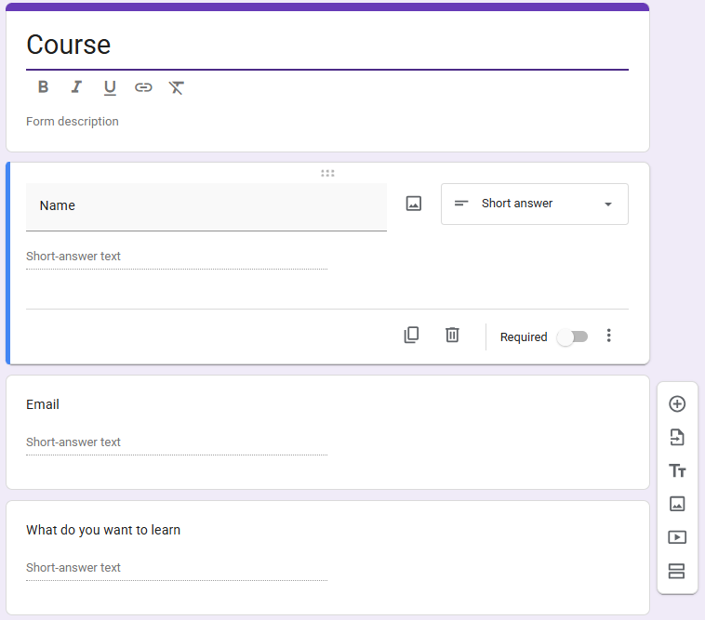

Step 2: Create the Google Sheet (The Database)
- At the top middle of your Google Form, click the Responses tab.
- Click the green Link to Sheets button (green square with a white cross).
- Select a destination:
  - Choose Create a new spreadsheet.
  - Leave the default name (your form's name with "(Responses)" added to it).
- Click Create.
- Your new Google Sheet will open, with column headers created automatically: Timestamp, Name, Email, and What do you want to learn.
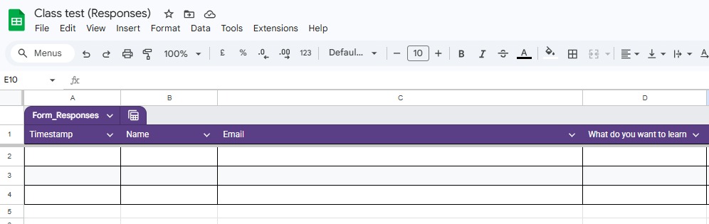

Phase 2: Building the Automation in Make.com
Step 3: Setting up the Trigger (Google Forms)
- Log into Make.com and click Create a new scenario in the top right corner.
- Click the giant purple + button in the middle of your screen.
- Search for Google Forms and click the purple icon.
- Select the Watch Responses module.
- Create a connection:
  - Click Add to securely log into your Google account.
- In the Form ID dropdown, select your Google Form created in Phase 1. Click OK.
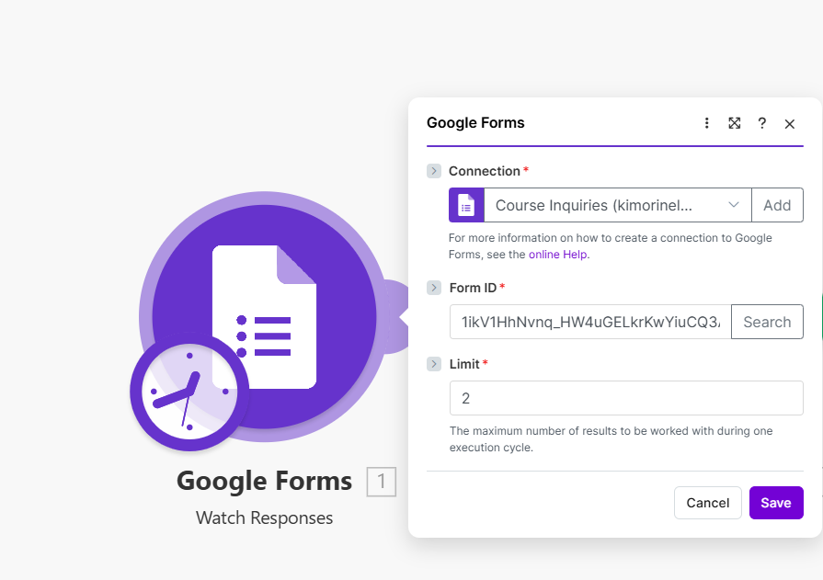
Crucial Step: Grabbing "Test Data"
- Right-click your Google Forms bubble and select Run this module only.
- Fill out your live Google Form (click the "Preview" eye icon) using a real email address and hit Submit.
- Return to Make.com to see a green checkmark indicating success.

Step 4: Setting up the Database (Google Sheets)
- Hover over the right side of the Google Forms bubble and click Add another module.
- Search for Google Sheets and click the green icon.
- Select Add a Row and connect your Google account.
- Select the specific Spreadsheet and Sheet name (usually "Form Responses 1").
- You will see empty boxes for your columns (Timestamp, Name, Email, etc.).
Step 5: The Art of "Mapping" Data
- Mapping the Timestamp (A):
  - Click the white box under Timestamp (A). In the purple menu, click Create Time.
- Mapping the Name (B):
  - Click the box under Name (B).
  - Expand: Answers -> Name -> textAnswers -> answers[]. Click the value variable.
  - (Add Screenshot 6: Mapping Name)
- Mapping the Email (C):
  - Click the box under Email (C).
  - Expand: Email -> textAnswers -> answers[]. Click the value variable.
- Mapping the Question (D):
  - Click the box under What do you want to learn (D).
  - Expand: What do you want to learn -> textAnswers -> answers[]. Click the value variable.
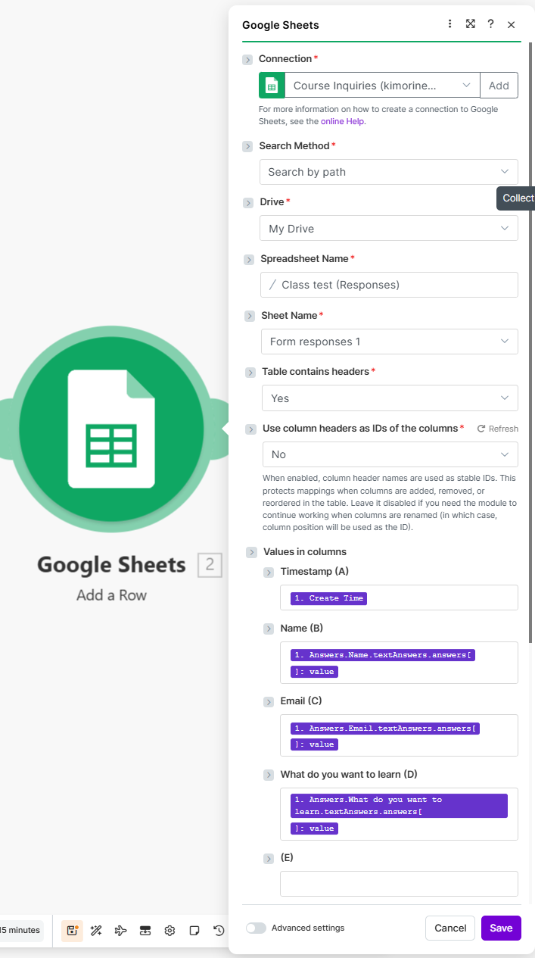
Step 6: Setting up the Communicator (Gmail)
- Hover over the right side of your green Google Sheets bubble and click Add another module.
- Search for Gmail, click the red icon, and select Send an email. Connect your account.
- To (Recipient): Map the email using the same process as before.
- Subject Line: Personalize it by including the Name variable (e.g., Welcome, [Name value]!).
- Content (Body): Write your welcome message, incorporating the Name and "What do you want to learn" values.
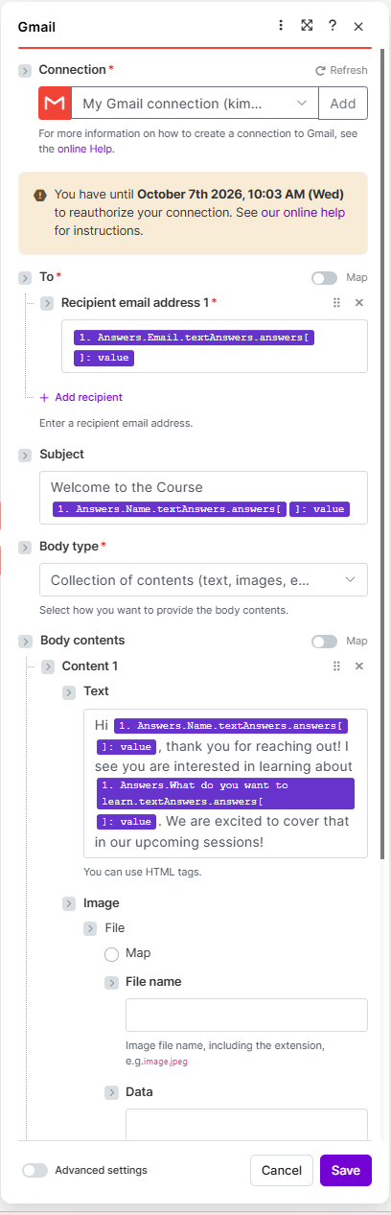
Step 7: Testing Your Machine
- Click the purple Run once button in the bottom left corner.
- Submit a new test via your live Google Form.
- Check for three green checkmarks on Make.com and verify the Google Sheet and your email for the new entry.
Step 8: Putting it on Autopilot
- Look at the bottom left corner of your screen.
- Toggle the switch that says Every 15 minutes to the right (it should turn purple).
- Click the Save icon (the floppy disk symbol) to lock it in.
Congratulations! You are officially an automation builder. Make.com will now monitor your Form and run this entire process every 15 minutes, completely hands-free!
Note: If you used your own Gmail address to fill out the form, the automated message might go straight into your "Sent" folder. Test it with a friend's email address to see it arrive in an Inbox.

